CMB SEATING ASSESSMENT FORM

Contact name: |  | Date:
Contact number: |  | Client Name:
Email: |  | Client Address:

Please provide information for any musculoskeletal or spine injuries you may have, including descriptions of any back pain you experience while seated and what makes that pain better or worse

Dimensions
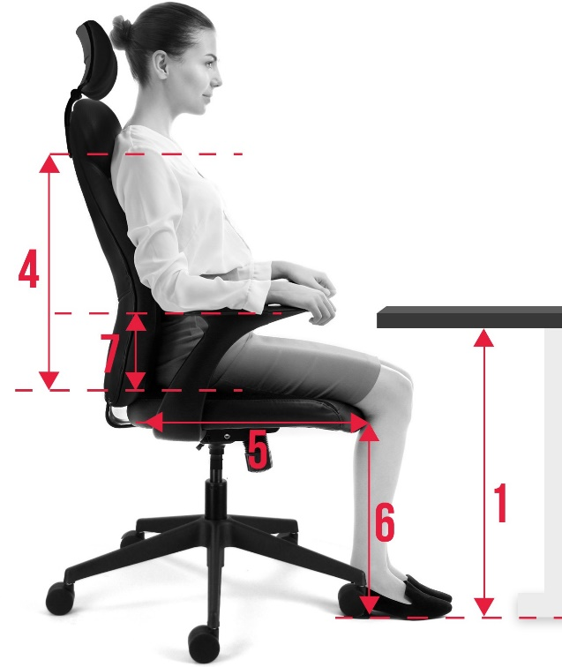 | Weight (stones/kilos):
 | Height (feet and inches:
 | 1. Desk height
 | 2. shoulder width
 | 3. Hip breadth
 | 4. seat to shoulder
 | 5. back of buttock to back of knee
 | 6. back of knee to floor
 | 7. Height of lumbar above seat
 | Do you require arms?
 | Desk shape, wave, corner, rectangle
 | Floor type
Any other Notes

